**Kol simcha torah gazette**

**For parshas Bo 5784**

Volume 8 Issue 19 (Whole #377) 10 Shevet 5784/ January 20, 2023

**Printed L’illuy nishmas Nechama bas R’ Noach, a”h**

For a free subscription, please forward your request to [***keren18@juno.com***](mailto:keren18@juno.com)

***Past emails can be found on the website ShabbosStories.com under Brooklyn Torah Gazette***

**The Importance of**

**Mesiras Nefesh**

**By Daniel Keren**

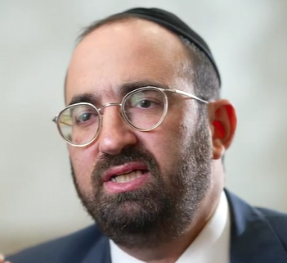

**Rabbi Joey Haber**

One of the featured speakers at the recent Flatbush Hakhel Yarchei Kallah Event for the December 25th legal holiday was Rabbi Joey Haber, the rabbinical director of Kesher and rabbi of Magen David Synagogue. The topic of his lecture was “What Makes Us, Us.”

Rabbi Haber began with the question: “Are kids today better that kids were 40 years ago?” His overall answer is that in certain categories such as learning or in one’s connection to Yiddishkeit, the kids of today are better. But, when it comes to the middot (character trait) of respect, it is possible that young people today are not as good as the kids of 40 years ago.

On the other hand, younger people today are in many ways more challenged that we were 30, 40 or 50 years ago. The major challenge, Rabbi Haber said, that our children have today is that of mastering mesiras nefesh (the character trait of self-sacrifice) when the need arises.

**Challenges to the Life and Dignity of Yehuda**

Rabbi Haber noted that we find six important issues that confronted Yehuda as recorded in the last parshas of Sefer Bereishis. Each of those important incidents in the life of Yehuda were challenges to his life and his dignity.

For example, when the episode of Tamar arose, he could have ignored her plea to identify the person to whom the deposit items belonged and was the father of her as yet unborn twin children. Rabbi Haber said that it was this and the other five issues of mesiras nefesh that Yehuda undertook that made him to be worthy that his descendants (the royal house of Dovid) were worthy to have the blessing of being king over the Jewish nation.

Rabbi Haber in his Hakhel lecture said that today you cannot find in Lakewood a Kollel yungerman who doesn’t have a leased car. In the old days those in Kollel used to drive old beaten-up station wagons that you had to tie a rope in order to make sure that the car bumper didn’t fall off. Our children today are missing the important quality of self-sacrifice.

**Willing to Make Such a Difficult Commitment**

When Yehuda told his father that he would guarantee his Olam Habah (portion in the World to Come) by promising to bring Binyomin back, Yehuda had no way of knowing that he would indeed be able to bring his younger brother back because the Viceroy was a “crazy” unpredictable personality. Yet Yehuda was willing to make such a commitment because of his commitment to try and bring back food so that his father would not starve.

Rabbi Haber said that the challenge for a husband today is to sacrifice what he wants to do in order to help his wife whether it is physical or emotional and requires a lot of time. Many marriages are severely challenged because of this lack of mesiras nefesh.

Even in the realm of chesed (kindness), all too often we get caught up in getting attention for good deeds. Do we avoid those acts of chesed that are not going to get us the appropriate attention that we privately crave for?

Leadership is dependent on one’s ability to make a commitment even when you don’t know how you are going to be able to carry out that promise. This is the essence of mesiras nefesh that any true leader must have.

Another important aspect of leadership is the ability to give of oneself for others without any though of what one can get for oneself.

Rabbi Haber concluded with the thought that what we are built on are not the people who are the most famous or the most influential, but rather with those of us who are willing to exhibit mesiras nefesh when the occasion arises. And that is why the descendant of Yehuda will be the Moshiach that we all look forward to.

*Reprinted from the Januay 11, 2023 edition of The Jewish Connection.*

**Rav Avigdor Miller on the**

**Importance of Speaking Yiddish**

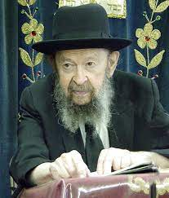

**QUESTION:** The Rav speaks often about the importance of speaking Yiddish. What about teaching in the yeshiva in Yiddish to a class that understands English better; is that the right way?

**ANSWER:** That’s not a moot question; it’s a very important question. It’s worth teaching Yiddish to Ashkenazi boys and girls because in a certain sense it maintains the tradition; it maintains a certain aloofness from the nations – it shows we are a separate people.

However, many times the message goes lost in an unfamiliar language. When they teach in a foreign language so the children who barely understand Yiddish are lost – and sometimes the subject matter is so difficult in itself that even in English it’s difficult and now you compound the difficulty by teaching it in Yiddish. And therefore, it’s a question.

Some children must have only English instruction. And even then it’s a question if they’ll succeed. Because the Torah subjects are not easy. Chumash for some children is a mountain. It’s remarkable how difficult it is for some children to climb that mountain. And then they need expensive tutors.

And Gemara?! Gemara is the Alps for some children; many fall down and become discouraged – they become disillusioned because of the difficulties of the studies. And if their difficulty is increased by using a foreign language like Yiddish, it’s a big problem.

And therefore, wherever possible English should be used until the child knows the subject. Then Yiddish should be introduced. Exactly how much Yiddish and how much English has to be left to the teacher on the spot.

*Reprinted from the Parshas Va’eira 5784 email of Toras Avigdor adapted from Tape #539 (January 1985))*

**Thoughts that Count**

*But against any of the Children of Israel, a dog shall not whet its tongue* (Ex. 11:7)

Animals, and particularly dogs, are the first to be aware of the approach of a natural catastrophe; their frenzied barking is often the first indication that anything is wrong. Thus, when the dogs in Egypt remained silent, it demonstrated that the slaying of the firstborn was a supernatural plague rather than an outbreak of illness or natural epidemic. *(Kol Omeir Kera)*

The dog is the most faithful and empathetic of all domestic animals. If someone in the household should die or be injured, a dog will make the most heart-rending noises to express its grief. Thus, after describing the terrible confusion that the slaying of the firstborn would cause - "there shall be a great cry throughout all the land of Egypt, such as there was none like it, nor shall be like it any more" - the Torah reassures us that the dogs in the Jewish sector would have no reason to bark. *(Rabbi Yeshayahu Horowitz of Vienna)*

*Reprinted from the Parshat Bo 5761/2001 edition of L’Chaim.*

**The Uniqueness of the Mitza**

**of Sanctifying the New Moon**

**From the Teachings of the Lubavitcher Rebbe**

**Rabbi Menachem Mendel Schneerson, Zt”l**

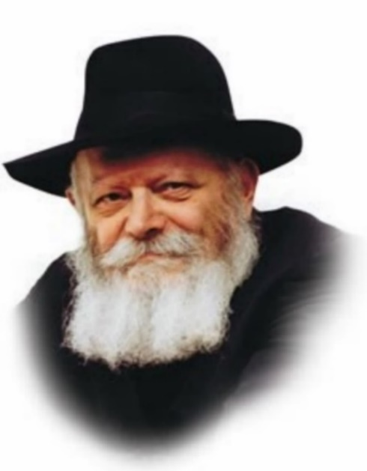

This week's Torah portion, Bo, contains the very first commandment given to the Jews as a people - the mitzva of Rosh Chodesh, the new moon: "This month shall be to you the first of months; it shall be the first month of the year to you." According to Jewish law, the new month is determined by witnesses who testify to the appearance of the new moon. The Jewish court then formally establishes and sanctifies it as Rosh Chodesh.

In general, the main effect the Torah's mitzvot have on the physical world is to imbue it with G-dliness. When a mitzva is performed with a physical object, the object itself becomes holy, and the material plane of existence is sanctified.

The mitzva of the new moon is unique in that instead of physical objects, it relates to the dimension of time. Through this mitzva, a "regular" day is transformed into Rosh Chodesh, a day with special sanctity. When the Jewish court decides to establish a particular day as Rosh Chodesh, time itself is elevated and made holy.

In this respect, the mitzva of sanctifying the new moon has an advantage over all other mitzvot. The ability of other mitzvot to bring sanctity into the world is limited, and exists on many levels and gradations. For example, an object directly used to perform a mitzva becomes a "tashmish kedusha," literally "a utensil of holiness." Other aspects of the physical world are elevated when a Jew uses them "for the sake of heaven." Then there are things that are only considered "tools" as preparation for the performance of an actual mitzva.

However, the mitzva of Rosh Chodesh is more far-reaching than all of these. When the Jewish court establishes a certain day as Rosh Chodesh, the effect is felt throughout the month, and indeed throughout the entire year, as the court also determines the occurrence of a leap year.

Another advantage to affecting the dimension of time is that time is generally thought of as something over which we have no control. Time cannot be made longer or shorter; it cannot be hurried up or slowed down. Nonetheless, G-d gives the Jew the ability to sanctify time and transform it into "Jewish time," time that is thoroughly imbued with holiness.

"Conquering" time in this way hastens the time when the entire world will be suffused with holiness, in the Messianic era. When Moshiach comes and gathers in the exiles of Israel, the Sanhedrin (Jewish supreme court) will be reestablished in Jerusalem, and the laws of Rosh Chodesh will again be in effect.

*Reprinted from the Parshat Bo 5761/2001 edition of L’Chaim. Adapted from Volume 26 of Likutei Sichot.*

**More Thoughts that**

**Count for Our Parsha**

*And there was a thick darkness in all the land of Egypt three days...they saw not one another* (Ex. 10: 22,23)

The worst kind of darkness is when people refuse to "see" each other and are uninterested in knowing about their fellow man. Indeed, the world is darkened when every individual lives only for himself. *(Eshkol Maamarim)*

*And the man Moses was very great in the land of Egypt, in the sight of Pharaoh's servants, and in the sight of the people* (Ex. 11:3)

There are many different kinds of public figures: Some personalities are better appreciated by the upper classes, while others are more popular among the common folk. Everyone, however, recognized Moses' greatness, from the highest-ranking Egyptian ministers to the lowest level of society. *(Rabbi Boruch Epstein)*

*Reprinted from the Parshat Bo 5761/2001 edition of L’Chaim.*

**Rabbi Berel Wein on**

**Parshat Bo 5784**

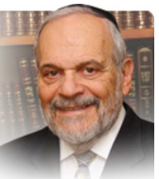

In this week's parsha the narrative of the Exodus from Egypt reaches one of its most climactic moments. Pharaoh finally succumbs to the pressures of the plagues and to the demands of Moshe and of the G-d of Israel. The last three plagues that are discussed in detail in this week's parsha are those of the locusts, darkness and the slaying of the firstborn.

These plagues represent not only physical damages inflicted on the Egyptians but also, just as importantly, different psychological pressures that were exerted on Pharaoh and the Egyptians.

The plague of locusts destroyed the Egyptian economy, or whatever was left of it after the previous seven plagues. Economic disaster always has far-reaching consequences. Sometimes those results can be very positive, such as the recovery of the United States from the Great Depression. Sometimes they are very negative, as the rise of Nazism in Germany in the 1920s and 1930s could not have occurred if it were not for the economic crisis that enveloped the Weimar Republic.

Here the economic crisis engendered by the plague of locusts brings Egypt to its knees, so that it is only the unreasoning stubbornness of Pharaoh that keeps the drama going. The next plague of darkness is one that affects the individual. Cooped up in one's home, unable to move about, blinded by darkness unmatched in human experience, the individual Egyptian is forced to come to terms with his or her participation in the enslavement of the Jewish people.

For many people, being alone with one's self is itself a type of plague. It causes one to realize one's mortality and to reassess one's behavior in life. This is not always a pleasant experience. Most of the time it is a very wrenching and painful one.

The final plague of the death of the firstborn Egyptians, aside from the personal pain and tragedy involved, spoke to the future of Egyptian society. Without children no society can endure - and especially children such as the firstborn, who are always meant to replace and carry on the work of their elders and previous generations.  We all want to live in eternity and since we cannot do so physically we at least wish it to happen spiritually, emotionally and psychologically.

The plague that destroyed the Egyptian firstborn destroyed the hopes of eternity that were so central to Egyptian society. The tombs of the leaders of Egypt were always equipped with food and material goods to help these dead survive to the future. Even though this was a primitive expression of the hope for eternity it nevertheless powerfully represents to us the Egyptian mindset regarding such eternity.

By destroying the firstborn Egyptians, the L-rd sounded the death knell for all of Egyptian society for the foreseeable future. It was this psychological pressure – which is one of the interpretations of the phrase that there was no house in Egypt that did not suffer from this terrible plague – that forced Pharaoh and his people to come to terms with their unjust enslavement of Israel and to finally succumb to the demands of Moshe and the G-d of Israel.

We should remember that all of these psychological pressures, even though they do not appear in our society as physical plagues, are still present and influential. The trauma of life is never ending.

*Reprinted from the current website of rabbiwein.com*

**Postmortem Organ Donations**

**By Rabbi Hillel Raskin**



**Rabbi Hillel Raskin**

May I sign a card to allow for organ donation?

Even after someone is unequivocally deceased as determined by halacha, there are three potential issues with using their organs or parts of their body:

**(1) Benefit from a deceased body:**

The Torah prohibits having benefit from a meis, and neither relatives nor the person himself can forgo this right. The prohibition is of course overridden in cases of pikuach nefesh, danger to life, but poskim debate whether a liver transplant constitutes pikuach nefesh, and a skin transplant certainly isn’t.

Still, some poskim argue that transplants never transgress benefitting from the deceased, since upon installing the organ in a live body, it becomes part of the living body and loses its previous status. Thus, there is no benefit from a “deceased.” However, others dispute this argument and hold that the organ retains its status, and the prohibition remains.

**(2) Nivul hames, desecrating the deceased body:**

Some poskim hold that a person can provide consent for his body to be desecrated after his passing, even in scenarios where there is no pikuach nefesh.

Some poskim posit that removing an organ to implant it in another body doesn’t constitute a desecration or disgrace in the first place.

**(3 ) Failure to bury this part of the deceased:**

There is debate whether the mitzva of kevurah is min haTorah or miderabanan.

According to the latter view, there is more room for leniency to forgo the mitzva for purposes of transplants, even when not pikuach nefesh.

When it comes to corneal transplants, there are additional grounds for leniency since the cornea is smaller than a kezayis, and many hold that the mitzvah min haTorah of kevurah only applies to a kezayis or larger.

In practice, poskim allowed a skin bank when the person consented during their lifetime, and Rav S. Z. Auerbach allowed taking skin from a deceased person only if there is someone with extensive burns who needs it here right now.

This complex shaila should be discussed with one’s rov for a psak.

*Reprinted from the Parshat Shemos 5784 edition of The Weekly Farbrengen. Rabbi Raskin is Rov of Anash in Petach Tikva, Israel*

*\*\*\*\*\*\*\*\*\*\*\*\*\*\*\*\*\*\*\*\*\*\*\*\*\*\*\*\*\*\*\*\*\*\*\*\*\*\*\*\*\*\*\*\*\*\*\*\*\*\*\*\*\*\*\*\*\*\*\*\*\*\*\*\*\*\**

And we will not know how we shall serve Hashem until our arrival there. (10:26) If a miracle is performed for a person the person is obligated to bring a Korban Todah - a sacrifice of thanksgiving. Moshe is telling Pharaoh that as of now we have no idea how many miracles Hashem will perform for us. Until we actually leave Mitzrayim and reach Har Sinai we will not know how many sacrifices we will be obligated to bring. (Ksav Sofer)

And Moshe said (to Pharaoh) “So said Hashem, ‘At midnight I shall go out in the midst of Mitzrayim. (11:4) Rashi says Moshe said at approximately midnight which means close to it either before it or after it, and he did not say at midnight lest Pharaoh’s astrologers err (as to when is exactly midnight) and say Moshe is a liar. But Hashem who knows his times and moments exactly said at midnight. When would Pharaoh’s astrologers say

*Reprinted from the Parshat Bo 5784 email of R’ Yedidye Hirtenfeld’s whY I Matter parsha sheet for the Young Israel of Midwood in Brooklyn.*

**Inspired by the Answer**

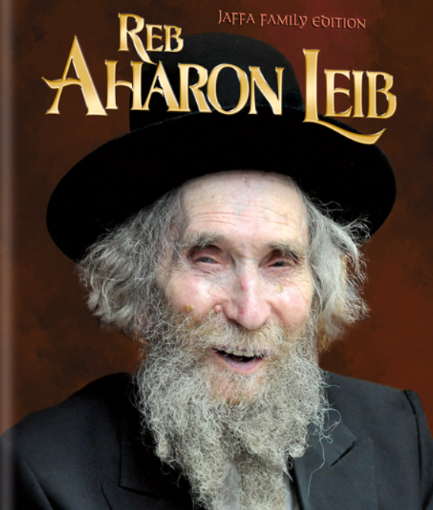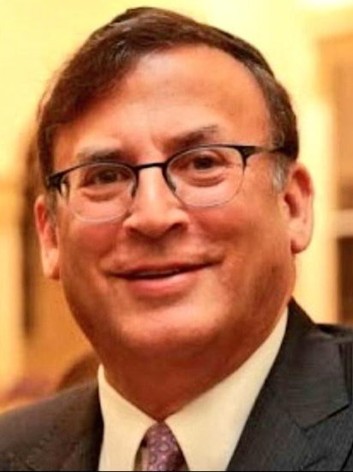

Rav David Ashear wrote how we hear many stories of how people were saved from difficult situation from Hashem, as a direct result of their heartfelt tefilos. It is not easy to daven emotionally every day, especially after years of not seeing the results that are hoped for.

Of course, we know that every tefilah is a mitzvah and will bring eternal rewards beyond anything we can comprehend, but we like to see results in this world as well. Sometimes, all people need is the right chizuk to give them an extra boost to Daven the way they are supposed to. Hashem could help us with that too!

Rav Ashear reports that Shevi (not the real name) told him that she was listening to a class given by Rav Zecharia Wallerstein, zt”l, and he mentioned that he one-time asked Rav Aharon Leib Shteinman, zt”l, for a brachah to open a dormitory for his girls’ school.

Rav Shteinman told him, “Who said it’s the will of Hashem that you should have a dormitory?” and he did not give the brachah for it. Some time passed, and it was becoming very difficult for Rav Wallerstein to make progress with the girls. When they went home every evening, they would lose much of what they had gained during the day.

A year after his first visit, Rav Wallerstein went back to Rav Shteinman and said, “Please, give me a brachah for a dormitory. We need it so badly!” This time Rav Shteinman gave him a warm brachah to have success.

Rav Zecharia wondered out loud, “What is the difference between last year and this year that the Rav gave me two such different responses?”

Rav Shteinman replied, “Last year, you said you wanted a dormitory. This year, you said you needed a dormitory. Just because you want something doesn’t mean it is good for you. But if you really need it, Hashem will help!”

Shevi was inspired by this lesson. She had been davening for years for her son to get married. He was having a hard time with shidduchim and it seemed that her tefilos were not helping. After listening to Rav Wallerstein’s class, she davened Minchah that day with renewed strength and kavanah. She put all her emotions into the Tefilah, and told Hashem how much her son needed a shidduch.

As she finished saying Aleinu, the phone rang. It was the shadchan calling with a new suggestion for her son, and Baruch Hashem, her son married the girl who was suggested that day!

Rav Ashear commented that Shevi’s tefilah emerged that afternoon from the depths of her heart. She just needed the right words of chizuk to bring it out of her. He noted that the main aspect of every tefilah is one’s heart and sincerity!

*Reprinted from the Parshas Va’eira 5784 email of Rabbi Yehuda Winzelberg’s Torah U’Tefilah.*

**The Miracle of the Transformation of Slaves**

R’ Joseph B. Soloveitchik z”l (1903-1993) observes: The most amazing thing about the Exodus, far greater than the signs and the wonders, is the transformation that occurred to a nation of slaves. Slaves do not understand the idea of obeying laws when no taskmaster threatens them.

Therefore, why would a slave obey the commands in our parashah such as matzah, such as korban Pesach, such as “You shall not break a bone of it,” or such as “You may not leave over any of it until morning” if no taskmaster is threatening?

The Sages applied to the generation of the Exodus the verse (Yechezkel 16:7), “You have increased and grown great . . . yet you are naked and bare.” The midrash explains: The generation was naked of commandments.

[R’ Soloveitchik continues:] Their life was a naked one, controlled by lusts and desires. And then there occurred the greatest miracle of all: “Bnei Yisrael went and did as Hashem commanded Moshe and Aharon, so did they do.”

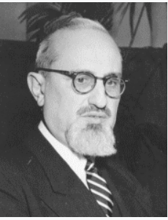

**Rav Joseph B. Soloveitchik z”l**

The slaves suddenly felt the duty of commandments, the power of a life devoted to higher ideas and goals. They understood what it means to possess spiritual ideals and what it means to enter into a covenant with the Almighty. Suddenly, they stood “hedged with roses” [a term used by the Sages to refer to the laws of family purity, which are kept in private and which no authority could possibly enforce.

These laws are in contrast to the lust-filled life of a person who recognizes no laws]. No one threatened them with batons, no taskmasters ran around shouting at them. They could have trampled everything, the roses and the glorious flower bed. But, suddenly, they beheld the power and beauty of the roses. This transformation was a hidden miracle of great import. The Jews were able to distinguish between sacred and profane. (Festival of Freedom)

*Reprinted from the Parshat Bo 5784 email of R’ Yedidye Hirtenfeld’s whY I Matter parsha sheet for the Young Israel of Midwood in Brooklyn.*